River Grove Public Library District (RGPLD)

- A brief description of our public body is as follows:

  - The River Grove Library District’s mission is to “Serve, Inspire and Empower” the community.
  - An organizational chart is attached.
  - The total amount of our appropriated operating budget for the current fiscal year is available on the library’s website. Funding sources are property taxes, state and federal grants, interest, fines, charges, and donations. Tax levies are:
      - Corporate levy (for general operating expenditures)
      - FICA (Social Security)
      - Illinois Municipal Retirement Find
      - Maintenance and Support Fund
      - Insurance levy
      - Audit
      - Worker’s Compensation
      - Unemployment
  - The office is located at this address: 8638 W. Grand Avenue, River Grove, IL 60171. We have approximately the following number of persons employed:
      - Full-time 3
      - Part-time 10

  - The following organization exercises control over our policies and procedures: The River Grove Public Library Board of Library Trustees, regularly meets monthly on the second Wednesday of each month, 6:30 p.m., at the library, unless specified differently in the Establishing Dates of Meetings Ordinance.

  - The River Grove Public Library District is a member of this library system: Reaching Across Illinois Library System (RAILS), 125 Tower Dr, Burr Ridge, IL 60527.

  - We are required to report and be answerable for our operations to: Illinois State Library, Springfield, IL.

- You may request the information and the records available to the public in the following manner:
      - Use request form (see attached).
      - Request information from River Grove Public Library, 8638 W. Grand Avenue, River Grove, IL 60171 (708-453-4484), weekdays during regular business hours, excluding holidays, or mail to the same address to the attention of the FOIA Officer.
      - You must indicate whether you have a “commercial purpose”¹ in your request.²
      - You must specify the records requested to be disclosed for inspection or to be copied. If you desire that any records be certified, you must specify which ones.
  - To reimburse us our actual costs for reproducing and certifying (if requested) the records, you will be charged the following fees:
      - There is a $1.00 charge for each certification of records.
      - There is no charge for the first fifty (50) pages of black and white text either letter or legal size.
      - There is a $.15 per page charge of copied records in excess of 50 pages.
      - There is a $1.00 charge per page for color copies and other sized copies.
  - If records are kept in electronic format, you may request a specific format and if feasible, they will be so provided, but if not, they will be provide either in the electronic format in which they are kept (and you would be required to pay the actual cost of the medium only, i.e. disc, diskette, tape, etc.) or in paper as you select.
  - Records may be inspected or copied. If inspected, an employee must be present throughout the inspection. Records for inspection only are available by appointment Monday through Friday, during regular business hours at River Grove Public Library District, Administration Office.
  - The office will respond to a written request within five (5) working days or sooner if possible. An extension of an additional five (5) working days may be necessary to properly respond.

- Certain types of information maintained by us are exempt from inspection and copying. However, the following types of categories of records are maintained under our control:
      - Monthly Financial Statements
      - Annual Receipts and Disbursements Reports – Treasurer’s Report
      - Budget and Appropriation Ordinances
      - Levy Ordinances
      - Operating Budgets
      - Minutes of the Board of Library Trustees
      - Library Policies
      - Adopted Ordinances and Resolutions of the Board
      - Annual Reports to the Illinois State Library

- The entire Freedom of Information Act is available at www.ilga.gov under Illinois Compiled Statues, Chapter 5 (General Provisions), ILCS 140 (5 ILCS 140).

Organizational Chart
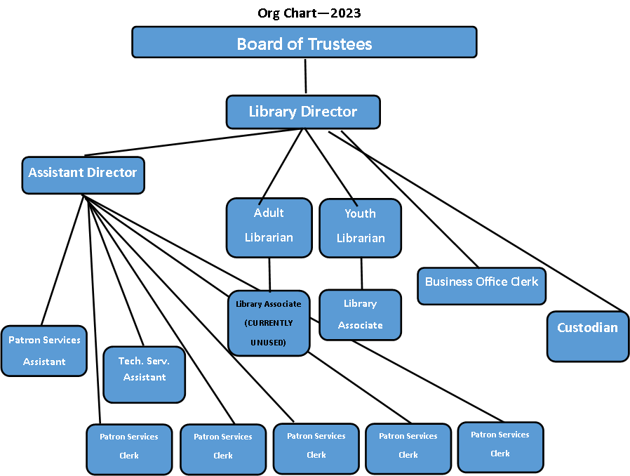

FOIA Request Form

Requestor’s Name (or business name, if applicable) | Date of Request | Phone number
Street Address | Certification requested:  ____Yes ____ No
City State Zip

Description of Records Requested:

Is the reason for this request a “commercial purpose” as defined in the Act? ___ Yes ___ No

Library Response (Requestor does not fill in below this line)
Approved | ( ) The documents requested are enclosed.  ( ) You may inspect the records at _____________________ on date of _________.  ( ) The documents will be made available upon payment of copying costs of $ ___________.  ( ) For “commercial requests” only: the estimated time of when the documents  will be available is _______________, at the prepaid costs stated above.
Denied | ( ) The request creates an undue burden on the public body in accordance with Section 3(g) of the Freedom of Information Act, and we are unable to negotiate a more reasonable request.  ( ) The materials requested are exempt under Section 7 ________________ of the Freedom of Information Act for the following reasons: ______________________________________  _________________________________________________________________________  Individual(s) that determined request to be denied and title: _________________________  ________________________________________________________________________.  In the event of a denial, you have the right to seek review by the Public Access Counselor at (217) 558-0486 or 500 S. Second St., Springfield, IL 62705 Or you have the right to judicial review under section 11 of FOIA.  ( ) Request delayed, for the following reasons (in accordance with 3(e) of the FOIA): ________. You will be notified by the date of ________as to the action taken on your request.
NOTE: This form cannot be MANDATORY under FOIA, but it is preferred.
FOIA Officer Date of Reply
__________________________________________ _____________________

