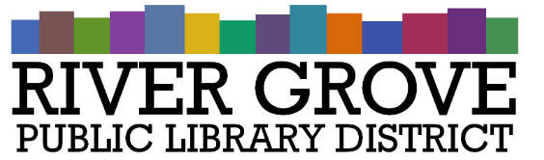
River Grove Public Library District
8638 W Grand Ave
River Grove, IL 60171
708.453.4484

Board Meeting Agenda
Date: 4/10/2024
Time: 6:30pm
Place: Library – Youth Room

- CALL TO ORDER

- GUESTS

- OPEN HEARING

- APPROVAL OF MINUTES
  - General Board Minutes – March 13, 2024

- CORRESPONDENCE

- TREASURER’S REPORT
  - Approval of March 2024 Treasurer’s Report

- BILLS FOR APPROVAL
  - Approval of Bills presented in April 2024
  - Approval of DAE Group invoice for $17,500

- PRESIDENT’S REPORT
  - President Conway’s Report

- LIBRARY STATUS REPORT
  - Director’s Report
    - Pilar Shaker’s introduction and three-month plan

- COMMITTEE REPORTS

- BUILDINGS AND GROUNDS

- OLD BUSINESS

- NEW BUSINESS
  - Approval of Budget 2024-2025
  - Approval of the IMRF Notice of Appointment of Authorized Agent for Pilar Shaker
  - Authorize Pilar Shaker to access and manage the bank account for maintenance of library finances

- PUBLIC COMMENTS

- EXECUTIVE SESSION

- ADJOURNMENT

