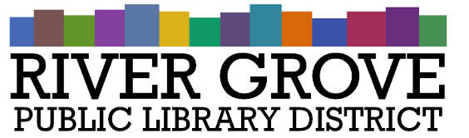
River Grove Public Library District
8638 W Grand Ave
River Grove, IL 60171
708.453.4484

Board Meeting Agenda

Regular Meeting

Date: 10/11/2023
Time: 6:30pm
Place: Library – Youth Room

- CALL TO ORDER

- GUESTS
a. Joe Huberty of Engberg Anderson Architects

- APPROVAL OF MINUTES
  - Regular Meeting Minutes – 9/13/2023

- CORRESPONDENCE
  - Cook County Clerk – Preliminary 2022 Agency Tax Rates

- TREASURER’S REPORT
  - Approval of September 2023 Treasurer’s Report (ACTION ITEM)

- BILLS FOR APPROVAL
  - Approval of Bills presented in October 2023 (ACTION ITEM)

- PRESIDENT’S REPORT

- DIRECTOR’S REPORT
  - State of the library
  - Library statistics

- COMMITTEE REPORTS

- BUILDINGS AND GROUNDS

- OLD BUSINESS
  - Owners Rep Selection (ACTION)
  - Renovation – 8301 W. Grand (ACTION)
  - Audit Firm Proposals (ACTION)
  - Updated Notice of Truth in Taxation Hearing (ACTION)
- NEW BUSINESS
  - Programming Policy – First Reading (ACTION)

- PUBLIC COMMENTS

- EXECUTIVE SESSION
- ADJOURNMENT

