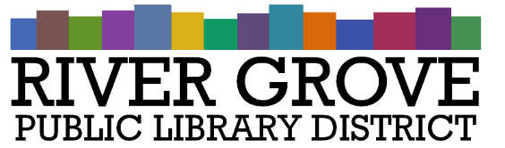
River Grove Public Library District
8638 W Grand Ave
River Grove, IL 60171
708.453.4484

Board Meeting Agenda
Date: 11/9/2022
Time: 6:00pm
Place: Library – Youth Room

- CALL TO ORDER

- GUESTS

- APPROVAL OF MINUTES
  - General Board Minutes – October 12th, 2022 (ACTION ITEM)

- CORRESPONDENCE

- TREASURER’S REPORT
  - Approval of October 2022 Treasurer’s Report (ACTION ITEM)

- BILLS FOR APPROVAL
  - Approval of Bills presented in November 2022 (ACTION ITEM)

- PRESIDENT’S REPORT

- DIRECTOR’S REPORT
  - State of the library
  - Library stats

- COMMITTEE REPORTS

- BUILDINGS AND GROUNDS

- OLD BUSINESS
  - Managed IT Vendor (ACTION ITEM)
  - Roof Repair (ACTION ITEM)
  - Review of Library Policies – Second Reading (ACTION ITEM)

- NEW BUSINESS

- PUBLIC COMMENTS

- EXECUTIVE SESSION
  - The Board of Library Trustees will meet in Executive Session under the exception of the Open Meetings Act ILCS Chapter 5, Act 120/2 (c) Exceptions: “The purchase or lease of real property for the use of the public body, including meetings held for the purpose of discussing whether a particular parcel should be acquired.”

- ADJOURNMENT

