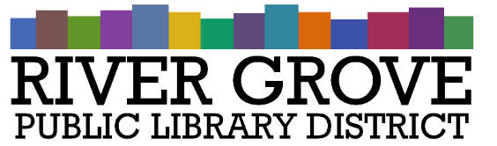
River Grove Public Library District
8638 W Grand Ave
River Grove, IL 60171
708.453.4484

SPECIAL MEETING AGENDA

WEDNESDAY, SEPTEMBER 27th, 2023
6:30 PM
YOUTH ROOM –
RIVER GROVE PUBLIC LIBRARY DISTRICT

I. CALL TO ORDER
II. OLD BUSINESS
a. 8301 W. Grand Renovation Project - Discussion
b. Owners’ Rep Proposals (POSSIBLE ACTION)
c. Architect Proposal – Reroofing Project (POSSIBLE ACTION)
IV. PUBLIC COMMENTS
V. ADJOURNMENT

